HERIOT - WATT UNIVERSITY

School of Engineering & Physical Sciences

Mechanical Engineering Laboratory

Arduino Experiments

Temperature sensing

## Introduction**:**

Knowing the temperature at a point is a very common task in many fields of engineering, and so for this task we will be carrying out a temperature reading using a simple electronic component known as a **thermistor**. A thermistor is a sensor that outputs a varying analogue voltage that is proportional to the ambient temperature. In this example you will learn how to acquire the sensor data and copy it into a spreadsheet file for analysis.

## Required Components:

* Arduino UNO
* Temperature sensor (TMP36)
* Breadboard
* Jumper cables

## Task:

Write a program to measure the voltage output of the sensor (this will be what you get when reading the sensor), temperature in degrees Celsius, and temperature in degrees Kelvin of your hand when placed on the thermistor. Then verify the result with a thermometer.

Use the data given from Serial Monitor and plot it in a spreadsheet.

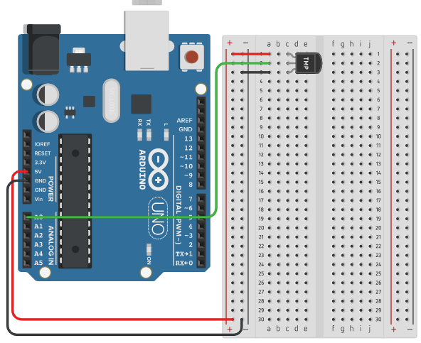

To show time mark “Show timestamp” in the bottom of Serial Monitor tab:



The serial monitor can be revealed by going to Tools -> Serial Monitor.

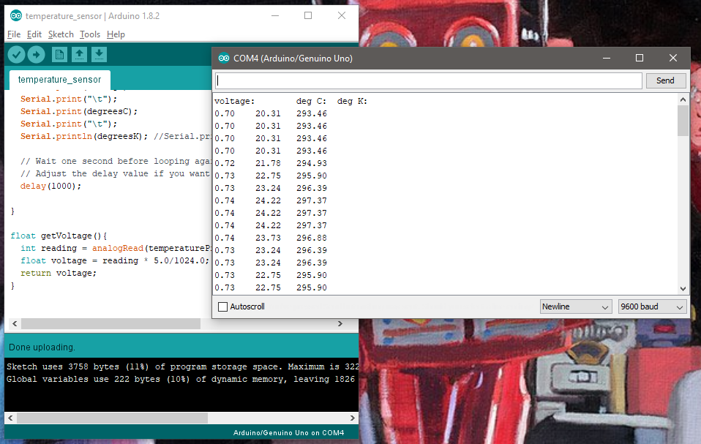

Unplug the Arduino from the USB cable. The serial monitor stops being updated. Select all of the data in the serial monitor window using the mouse. Copy (ctrl + C) the data, then open a new file in Excel. Paste the data into a cell and the temperature measurements appear. 